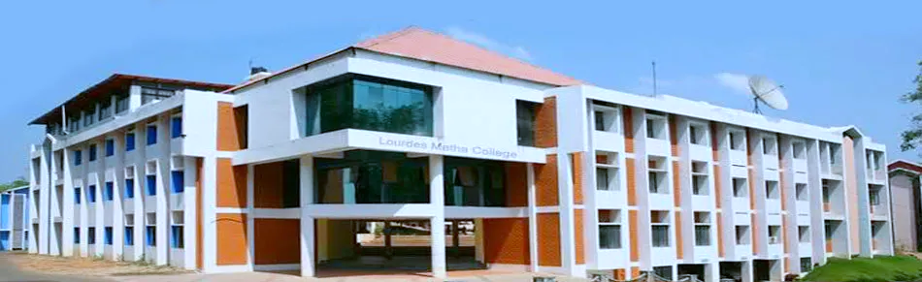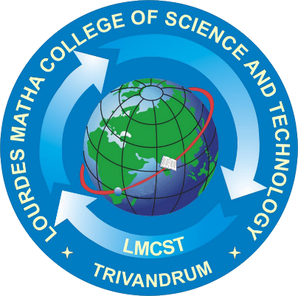

**MASTER OF COMPUTER APPLICATIONS (MCA)**



**LOURDES MATHA COLLEGE OF SCIENCE AND TECHNOLOGY**

**(MANAGED BY THE ARCHDIOCESE OF CHANGANASSERY)**

**KUTTICHAL, THIRUVANANTHAPURAM-695574**

**PHONE : 0472-2853550,2853682,2853546**

**WEBSITE : www.lmcst.ac.in**

**LOURDES MATHA COLLEGE OF SCIENCE AND TECHNOLOGY KUTTICHAL, THIRUVANANTHAPURAM-695574**

**(MANAGED BY ARCHDIOCESE CHANGANASSERY)**